**The Soundbytes (Team 11)**

*The Soundbytes* has developed a new core infrastructure for the university’s Robot Orchestra outreach project. The project combines engineering with music and art into a single application that can appeal to a wide audience and advertises engineering to people who might not normally consider it. This final year project was motivated by the rising public and industrial interest in the existing Robot Orchestra which, when expanded with the new core, will have greater flexibility, reliability and showcase industrial-standard equipment in an exciting non-traditional way.

The aim of the project was to increase the existing orchestra’s capabilities and allow for a wider selection of musical styles to be played while also allowing for the new instruments to be used as a standalone band. The objectives of the project were to select, design, manufacture and integrate four new instruments, as well as an electronic conductor, and assemble them into a core orchestra that can play together. The instruments that have been developed for this project are: a keyboard (Figure 1), steppers motors (Figure 2), Tesla coils (Figure 3), all using a Teensy board as a controller and a novel xylophone (Figure 4) that uses National Instruments’ myRIO. The electronic conductor is based on a Raspberry Pi that sends all the necessary information to each instrument via WiFi. The instruments can play both individually as well as jointly songs such as *Californication* by the *Red Hot Chilli Peppers*, the *Game of Thrones Main Theme* and *Happy Birthday*. The system has been designed with expandability in mind, allowing for future songs and instruments to be easily added. Additionally, it has been designed to allow for easy transportation and set up, making it suitable for use in many different locations and venues.

The project showcases the operation of multiple embedded systems to perform a shared task and it has a dual commercial applicability. First, the Soundbytes orchestra can be used at trade shows and other expo events by technology companies such as National Instruments (myRIO), ARM (Teensy Board) or Broadcom (Raspberry Pi) to showcase their products that are being used in this atypical application. Secondly, as the project can raise the profile of engineering, it can support corporate social responsibility agendas as well as the governments STEM and STEAM initiatives. The orchestra will also be available as an interactive engagement tool during university open days. To date, the project has been used for a university-hosted outreach event, the IET Faraday Challenge, where it was greatly appreciated by approximately 40 Year 8 students. The team is delighted to announce that it has also been accepted to Manchester Museum of Science and Industry’s competitive *MakeFest* event (26th May) which is a family friendly festival aimed at raising the interest of the general public in making and engineering. This goes to demonstrate the high interest in this project and its substantial social-good and commercial potential.

**Figure 2.** Stepper Motors Instrument

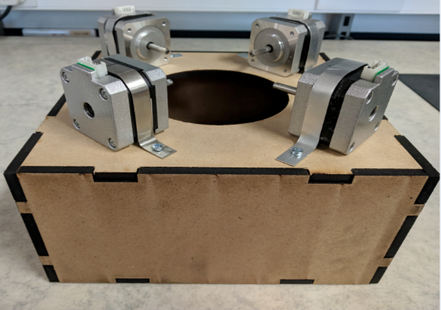

**Figure 1.** Keyboard.

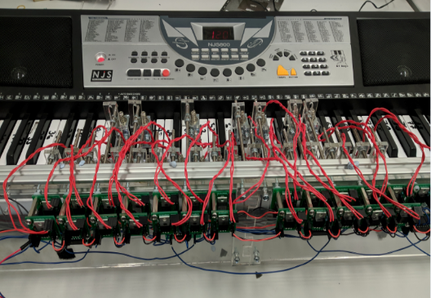

**Figure 4.** Xylophone.

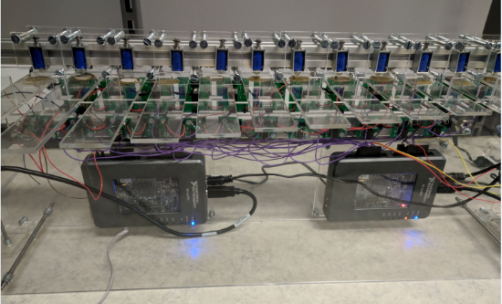

**Figure 3.** Tesla Coil Instrument.

